Bank Churn Analysis Report
Submitted by: vundhyala pradeep reddy

Objective Questions
- What is the distribution of account balances across different regions?
Answer:
The average account balance varies significantly across the three geographic regions: Germany, France, and Spain.
Visualization:
Average Account Balance by Region
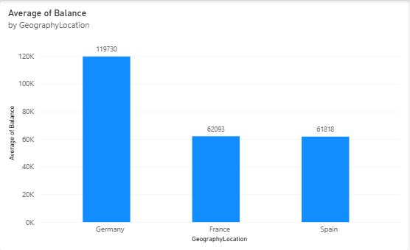
Insights:
- Germany has the highest average account balance at approximately 119,730.
- France has an average balance of approximately 62,093.
- Spain has the lowest average balance at approximately 61,818.
- Germany's average account balance is nearly twice that of France and Spain, while France and Spain have relatively similar average balances.

Conclusion: Germany has substantially higher average customer account balances than France and Spain. This difference may indicate greater average deposits per customer in Germany, although additional information would be needed to explain the underlying reasons.

- Identify the top 5 customers with the highest Estimated Salary in the last quarter of the year.
Answer:
The following five customers had the highest estimated salaries among customers who joined the bank during the last quarter of 2019 (October–December).
Visualization:
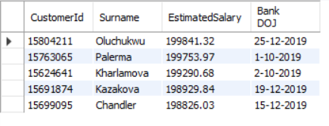

Insights:
- Oluchukwu had the highest estimated salary among the five customers, at 199,841.32.
- All five customers had estimated salaries above 198,000.
- The salary values are relatively close, indicating that these five customers belong to a similar high-estimated-salary range.
Conclusion: These customers represent the five highest estimated salary records for the selected quarter. Estimated salary reflects income estimates, not the actual account balance or deposits held by these customers.

3. Calculate the average number of products used by customers who have a credit card.
Answer:
The average number of products used by customers holding a credit card is 1.53
Visualization:
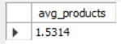
Insights:
- The average indicates the typical number of bank products used by customers who hold a credit card.
- This metric helps the bank understand product usage among credit-card holders.
- The result can support decisions about cross-selling additional banking products.
Conclusion:
Analysing the average number of products used by credit-card holders helps the bank understand their product usage and identify opportunities to encourage customers to use additional banking services.

4.Determine the churn rate by gender for the most recent year in the dataset.
Answer:
The churn rate by gender measures the percentage of customers who exited the bank within each gender group during the most recent year in the dataset.
Visualization:
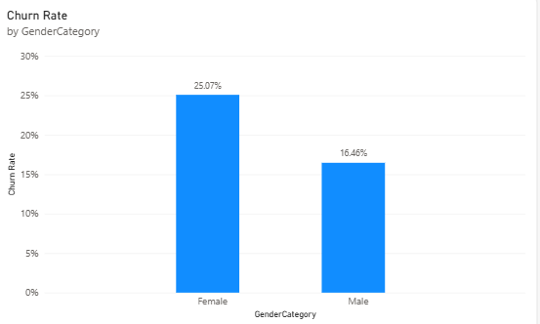
Insights
- Female customers had a churn rate of approximately 25.07%.
- Male customers had a churn rate of approximately 16.46%.
- The overall dashboard figures show a higher churn rate among female customers than male customers.
Conclusion
The results indicate that female customers have a higher churn rate than male customers in the overall dataset. However, the question asks specifically for the most recent year, so the yearly figures must be filtered and verified before finalizing this conclusion for that period.

5. Compare the average credit score of customers who have exited and those who remain.
Answer:
The average credit scores of customers who exited the bank and those who remained are compared to identify differences in their credit profiles.
Visualization:
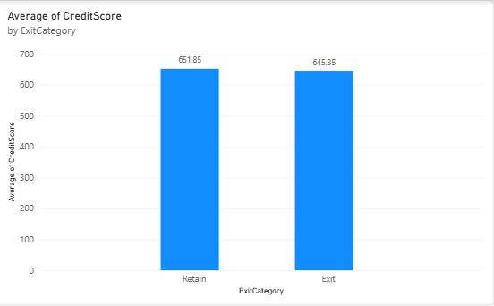

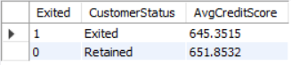

Insights:
- Retained customers have an average credit score of 651.8532.
- Exited customers have an average credit score of 645.3515.
- The difference between the two groups is approximately 6.50 points.
- This suggests that retained customers have a slightly higher average credit score, although the difference alone does not establish that credit score causes customer churn.
Conclusion:
The average credit score is slightly higher among retained customers than among exited customers. The bank can consider credit score alongside other customer characteristics when investigating churn patterns.

6. Which gender has a higher average estimated salary, and how does it relate to the number of active accounts?
Answer:
Female customers have a higher average estimated salary, while male customers account for a higher number of active accounts.
Results:
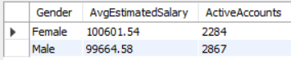
Insights
- Female customers have an average estimated salary of 100,601.54, which is 936.96 higher than the male average of 99,664.58.
- Male customers have 2,867 active accounts, compared with 2,284 for female customers.
- Although female customers have a slightly higher average estimated salary, male customers have 583 more active accounts.
- These results show that higher average estimated salary does not necessarily correspond to a higher number of active accounts.
Conclusion
Female customers have a slightly higher average estimated salary, whereas male customers account for more active accounts. The bank can use these findings to explore gender-specific engagement strategies while considering other factors that may influence account activity.

7. Segment the customers based on their credit score and identify the segment with the highest exit rate.
Answer
The low credit-score segment has the highest exit rate at 22.02%, compared with the medium and high credit-score segments.
Results:
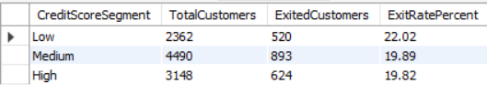

Insights:
- The low credit-score segment has the highest exit rate at 22.02%.
- The medium segment has the largest number of exited customers, with 893 exits, because it also contains the largest number of customers.
- The high segment has the lowest exit rate at 19.82%.
- The difference between the low and high segments is 2.20 percentage points.
Conclusion:
Customers in the low credit-score segment have a higher exit rate than those in the medium and high segments. The bank could examine this group more closely when developing customer-retention strategies, while considering other factors that may influence churn.

8. Find out which geographic region has the highest number of active customers with a tenure greater than 5 years.
Answer:
France has the highest number of active customers with a tenure greater than five years, with 797 customers.
Results:
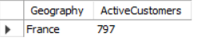

Insights:
- France has 797 active customers whose tenure exceeds five years.
- These customers represent an established customer segment that the bank may seek to retain through suitable engagement strategies.
Conclusion:
Based on the SQL query results, France is the leading geographic region for active customers with more than five years of tenure. The bank can investigate the characteristics of these long-term active customers to identify practices that may support customer retention.

9. What is the impact of having a credit card on customer churn, based on the available data?
Answer:
Customers without a credit card have a slightly higher churn rate than customers who have a credit card.
Visualization:
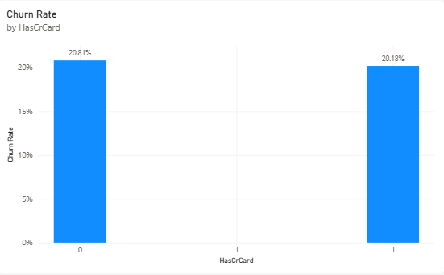

Insights:
- Customers without a credit card have a churn rate of 20.81%.
- Customers with a credit card have a churn rate of 20.18%.
- The difference is 0.63 percentage points, with the higher churn rate among customers without a credit card.
- The difference is relatively small, so credit-card ownership alone may not explain substantial differences in customer churn.
Conclusion:
Credit-card holders have a slightly lower churn rate than non-holders in this dataset. The bank could examine credit-card usage alongside other customer characteristics when developing retention strategies. These figures show an association, not proof that having a credit card causes customers to stay.

10. For customers who have exited, what is the most common number of products they have used?
Answer:
Among customers who exited the bank, using one product was the most common category, accounting for 1,409 exited customers in the provided results.
Results:
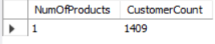
Insights:
- A total of 1,409 exited customers used one bank product.
- This indicates that one-product customers form a substantial group among those who left the bank.
- The result may help the bank investigate whether customers using fewer products have different retention needs.
Conclusion:
One product is the most common product count among exited customers in the provided output. The bank could examine whether offering relevant additional products improves engagement and retention, while validating this against the churn rate for each product-count group.
11. Examine the trend of customers joining over time and identify any seasonal patterns (yearly or monthly).
Answer:
Customer joining increased every year from 2016 to 2019. The monthly results also show noticeable variations, with November, December, and September recording the highest joining counts.
Results:
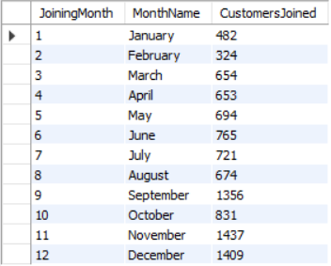
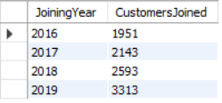
Insights:
- Customer joining increased from 1,951 in 2016 to 3,313 in 2019, an increase of approximately 69.8%.
- The highest yearly joining count occurred in 2019.
- November recorded the highest monthly count, with 1,437 customers, followed by December with 1,409 and September with 1,356.
- February recorded the lowest monthly count, with 324 customers.
- The monthly figures suggest possible seasonal variation, with higher joining counts in September and the final two months of the year. However, these totals combine all years, so they do not independently confirm a recurring seasonal pattern.
Conclusion:
Customer acquisition increased consistently over the four-year period. The monthly totals show higher joining activity in September, November, and December. The bank could investigate these periods further to determine whether marketing campaigns, business cycles, or other factors contributed to the higher counts.

12. Analyse the relationship between the number of products and the account balance for customers who have exited.
Answer:
The average account balance varies depending on the number of products used by customers who exited the bank. Customers using four products have the highest average balance, while those using three products have the lowest.

Visualization:
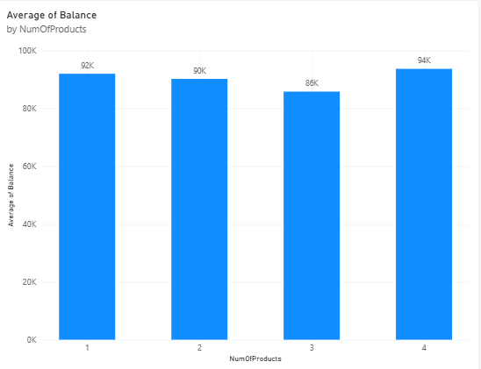
Filter: Exited=1

Insights:
- Customers using four products have the highest average account balance, approximately 94K.
- Customers using one product have an average balance of approximately 92K.
- Customers using two products have an average balance of approximately 90K.
- Customers using three products have the lowest average balance, approximately 86K.
- The average balance does not increase consistently as the number of products increases.
Conclusion:
Among exited customers, average account balances differ across product-count groups. Customers using four products have the highest average balance in the chart, but this pattern does not establish that using more products causes customers to exit. Other customer characteristics should also be considered.

13. Identify any potential outliers in terms of balance among customers who have remained with the bank.
Answer:
The scatter chart indicates that most customer balances are concentrated in the main cluster, while a small number of customers have unusually high balances. Some customers also have zero balances.
Visualization:
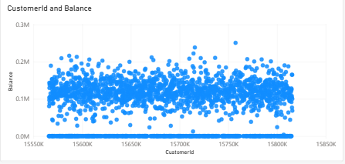
Insights:
- Most balances are concentrated approximately between 50,000 and 200,000.
- A few points extend above the main cluster, reaching approximately 250,000. These may be potential high-balance outliers.
- Several customers have zero balances, which may be valid records rather than errors.
- The dense distribution makes it difficult to determine the exact outlier count from the chart alone.
Conclusion:
The scatter chart suggests that some retained customers have unusually high balances compared with the main group. These values could be investigated further using a statistical method such as the interquartile range (IQR) to confirm whether they qualify as outliers.

14. How many different tables are given in the dataset, and which table consists only of categorical variables?
Answer:
The dataset contains 7 tables in the Power BI data model. The gender table consists of a gender identifier and a gender category.
Visualization:
Not required. This question is answered by inspecting the tables in Power BI Data view.
Insights:
The seven tables in the data model are:
- Bank_Churn
- CustomerInfo
- geography
- gender
- exit_customer
- credit_card
- active_customer
The gender table contains two columns:
- GenderID — identifies each gender category.
- GenderCategory — contains the categories Male and Female.
Both columns represent categorical information, with GenderID serving as a category identifier.
Conclusion:
The dataset contains seven tables, and the gender table contains only categorical information, as confirmed by its two columns in Power BI Data view.

15. Find the gender-wise average income in each Geography ID and rank the genders according to the average value.
Answer:
The average estimated income differs by gender across the three Geography IDs. The gender with the higher average income receives Rank 1 within each geography.
Results:
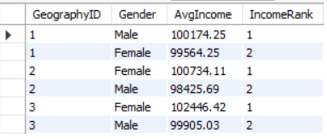
Insights:
- Geography ID 1: Male customers have a higher average income of 100,174.25, compared with 99,564.25 for female customers.
- Geography ID 2: Female customers have a higher average income of 100,734.11, compared with 98,425.69 for male customers.
- Geography ID 3: Female customers have the highest average income among the displayed groups, at 102,446.42.
- The gender with the higher average income differs by geography, showing that the pattern is not consistent across all regions.
Conclusion
Male customers have the higher average income in Geography ID 1, while female customers have the higher average income in Geography IDs 2 and 3. The bank can use these differences to better understand customer income profiles across geographic segments.

16. Find the average tenure of exited customers in each age bracket.
Answer:
The average tenure of exited customers is similar across all three age brackets, ranging from 4.82 to 4.88 years.
Results:
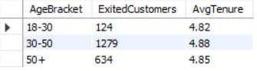
Insights:
- The 30–50 age bracket has the highest average tenure at 4.88 years and the largest number of exited customers, at 1,279.
- Customers aged 50 and above have an average tenure of 4.85 years, with 634 exits.
- The 18–30 age bracket has the lowest average tenure at 4.82 years and the fewest exited customers, at 124.
- The difference between the highest and lowest average tenure is only 0.06 years, indicating relatively similar average tenure across the groups.
Conclusion:
Exited customers across all age brackets had a similar average tenure of approximately 4.8–4.9 years. The 30–50 age bracket accounts for the largest number of exits, so the bank could examine this segment further when investigating customer churn.

17. Is there any direct correlation between salary and the balance of the customers? And is it different for people who have exited or not?
Answer:
No correlation found since the correl value is close to zero

Results:

Exited | -0.01254045473
Retain | 0.01719857062

Insights
- A higher estimated salary does not necessarily mean a higher account balance.
- Comparing exited and retained customers may reveal differences in their financial patterns.
- The correlation between salary and balance has not yet been confirmed statistically.
Recommendations
- Analyze salary and balance together for both customer groups.
- Investigate customers with unexpectedly low balances relative to their estimated salaries.
- Use correlation analysis to verify the relationship before making decisions.
- Avoid using salary alone to predict customer churn.

18. Is there any correlation between the salary and the Credit score of customers?
Answer:
No correlation found since the correl value is close to zero
- -0.001384292868
Approach:
- Formulas used to get the correlation between salary and balance
- =CORREL(Bank_Churn!O2:O10001,Bank_Churn!C2:C10001)

19. Rank each bucket of credit score as per the number of customers who have churned the bank.
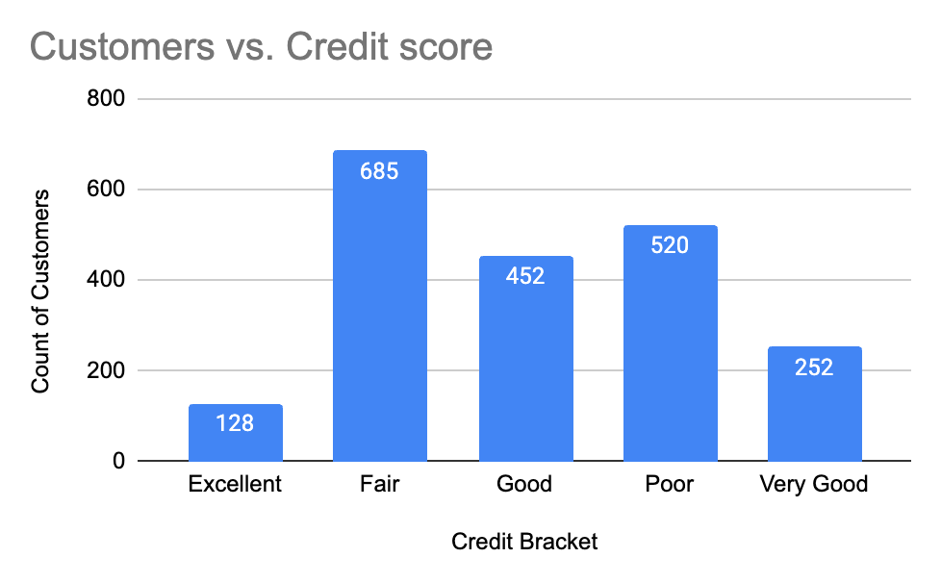
Approach:
- Created credit bracket using IF formula: =IF(C2>=800, "Excellent",If(C2>=740,"Very Good", If(C2>=670, "Good", If(C2>=580,"Fair", "Poor"))))
- Created pivot table keeping credit bracket in rows and count of customer_id in values, filtered by “exit”
- Bar chart is used to visualize

20. According to the age buckets find the number of customers who have a credit card. Also retrieve those buckets that have lesser than average number of credit cards per bucket.
Answer:
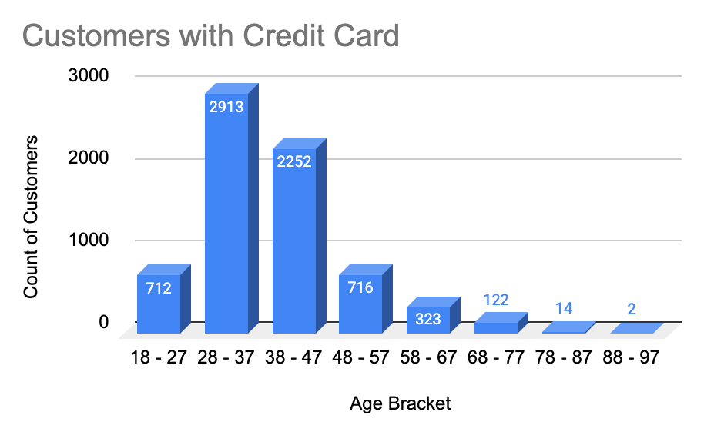

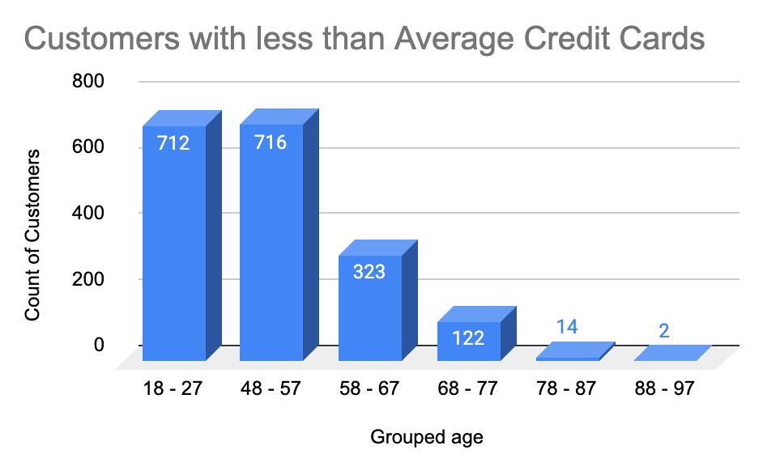

Approach:
- Created pivot table with age and credit card columns and filtered with “credit card holder”
- Grouped the age to age brackets using group pivot
- Find the average no. of credit card using formula =IF(B22< AVERAGE($B$7:$B$14),"Low","High") to find the buckets that have lesser than average number of credit cards per bucket
- Created bar chart for visualization

21. Rank the Locations as per the number of people who have churned the bank and average balance of the customers.

Answer:
The chart shows that Geography 3 has the highest number of churned customers (814), closely followed by Geography 1 (810). Geography 2 has the lowest number (413).

Visualization:
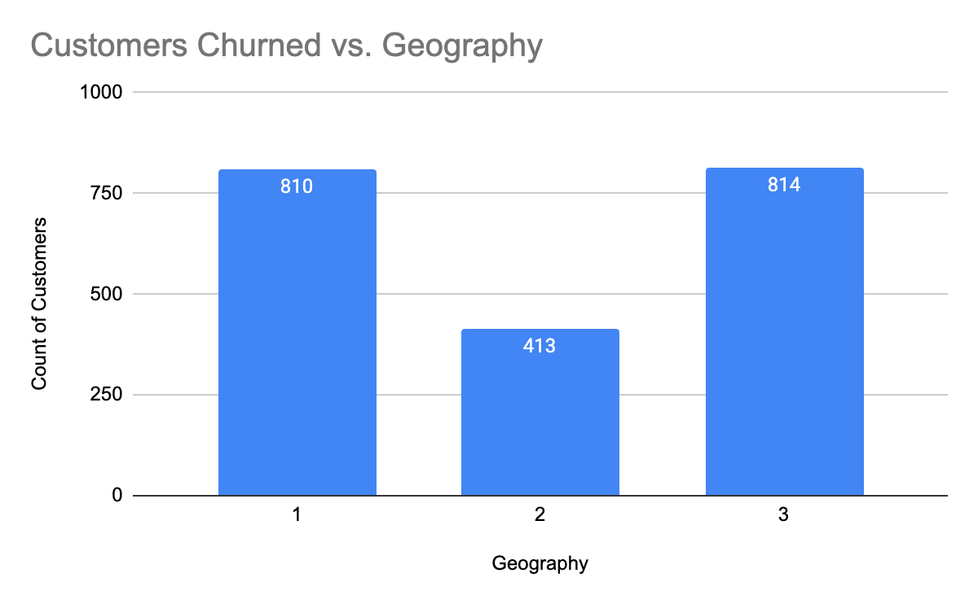

Insights:

- Geography 3 has the highest churn count, with 814 customers.
- Geography 1 follows closely with 810 churned customers.
- Geography 2 has the lowest churn count, at 413.
- Average balance is not displayed in the provided chart, so the locations cannot yet be ranked by average balance.

Conclusion:

Geography 3 and Geography 1 account for the highest numbers of churned customers and should be prioritized for further investigation. To complete the requested ranking, include the average balance of churned customers for each geography.

22. As we can see that the CustomerInfo table has the CustomerID and Surname, now if we have to join it with a table where the primary key is also a combination of CustomerID and Surname, come up with a column where the format is CustomerID_Surname.
Answer:
A calculated column can combine CustomerID and Surname with an underscore (_) between them to create a composite key.
Visualization:
CustomerId | Surname | CustomerID_Surname
15634602 | Hargrave | 15634602_Hargrave
15647311 | Hill | 15647311_Hill
15619304 | Onio | 15619304_Onio
15701354 | Boni | 15701354_Boni
15737888 | Mitchell | 15737888_Mitchell
15574012 | Chu | 15574012_Chu

Insights:
- The new column combines the customer ID and surname into one value.
- This format can help match records in another table using the same composite key format.

Conclusion:
Creating a CustomerID_Surname column provides a combined identifier that can be used to match customer records across tables. Ensure both tables use the same format for accurate matching.

23. Without using “Join”, can we get the ExitCategory from ExitCustomers table to Bank_Churn table? If yes, do this using SQL.
Answer:
Yes. We can retrieve the ExitCategory from the ExitCustomers table without using an explicit JOIN by using a subquery or a correlated subquery.
Results:
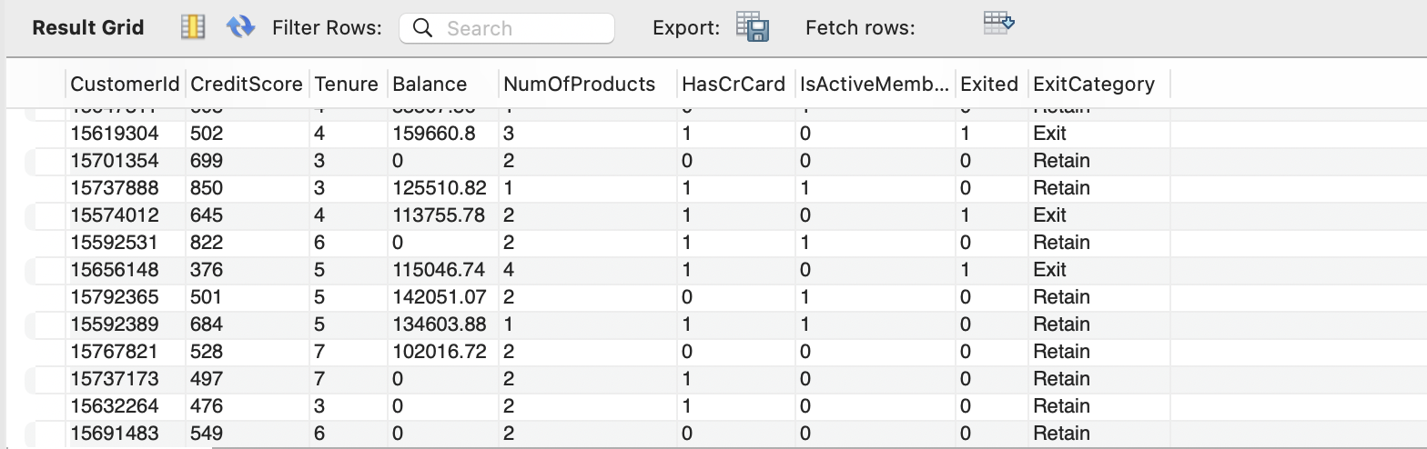

Insights:
- A subquery can retrieve matching exit categories using CustomerId.
- This approach avoids writing an explicit JOIN clause.
- Matching customer IDs correctly is important for accurate results.
Conclusion:
The ExitCategory can be retrieved without an explicit JOIN by using a subquery that matches customer IDs. Ensure the query maps each category to the correct customer.

24. Were there any missing values in the data, using which tool did you replace them and what are the ways to handle them?

Answer:
No missing values
Approach
- Count blanks to find the missing values
- Methods to handle missing values : find and replace, isblank()

25. Write the query to get the customer IDs, their last name, and whether they are active or not for the customers whose surname ends with “on”.
Answer:

Results:
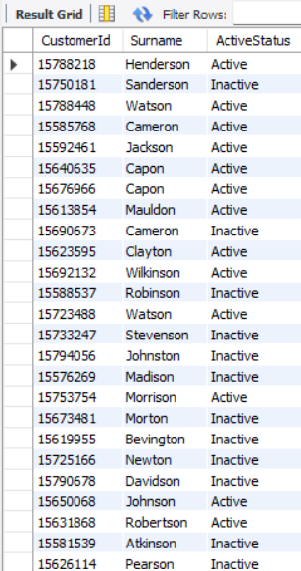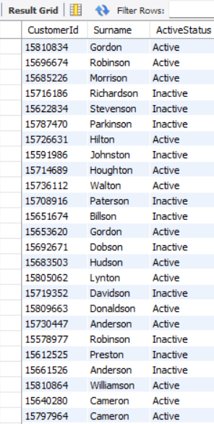

Insights:
- The query identifies customers whose surnames end with “on”.
- The results include both active and inactive customers.
- The output displays membership status as readable labels: Active and Inactive.

Conclusion:
The query successfully retrieves customer IDs, surnames, and active statuses for customers whose surnames end with “on”, helping identify membership activity within this group.

26. Can you observe any data disruption in the customer's data? As a hint, it's present in the IsActiveMember and Exited columns. One more point to consider is that the data in the Exited column is absolutely correct and accurate.
Answer:
Yes, potential inconsistencies can be identified by comparing IsActiveMember and Exited. Since Exited is confirmed to be accurate, it should be treated as the reference when investigating the records.
- Used formula =IF(J2=1,0,H2) to update the active member column
- When J2 (exited) is true then active_member should be false.

SUBJECTIVE QUESTIONS

1. What patterns can be observed in the spending habits of long-term customers compared to new customers, and what might these patterns suggest about customer loyalty?
Answer:
The chart shows that the total number of products varies across customer tenure groups. Customers with a tenure of 4 years have the highest total number of products, followed by those with 5 and 6 years. However, this chart measures product counts, not spending habits directly.

Visualizations:
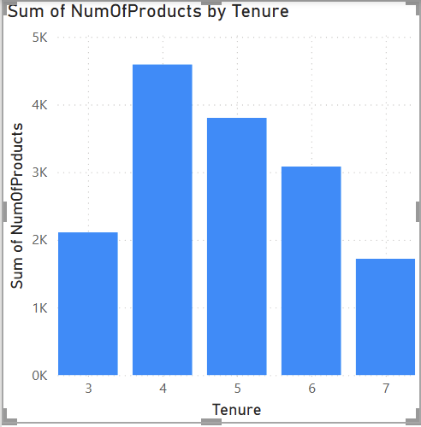
Insights:
- Customers with 4 years of tenure have the highest total product count.
- Total product counts decrease as tenure increases from 4 to 7 years.
- Product usage alone does not establish customer loyalty or spending patterns.
Conclusion:
Customer tenure and product usage show variation across groups. To assess customer loyalty and spending habits more accurately, compare average account balance and churn rate between new and long-term customers.

2. Which bank products or services are most commonly used together, and how might this influence cross-selling strategies?
Answer:
The dataset contains the number of products held by each customer and whether they own a credit card. However, it does not specify the individual banking products, so exact product combinations cannot be identified.
Insights:
- Analyze product counts alongside credit card ownership to identify customer usage patterns.
- Customers with fewer products could be considered for relevant additional services.
- Cross-selling strategies should be based on customer needs and observed usage patterns.
Conclusion:
The bank can use product-count and credit-card data to guide cross-selling opportunities. More detailed product-level data would be required to identify which specific products are commonly used together.

3. How do economic indicators in different geographic regions correlate with the number of active accounts and customer churn rates?
Answer:
The chart compares customer counts across France, Germany, and Spain. France has the largest customer base, while Germany and Spain have smaller customer counts. However, the chart alone does not establish a relationship between regional economic indicators and customer churn.
Visualizations:
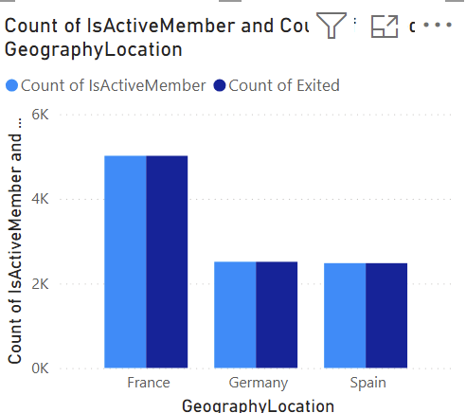
Insights:
- France has the largest customer count among the three regions.
- Germany and Spain have comparatively smaller customer bases.
- External economic data is needed to determine whether economic conditions influence customer activity or churn.
Conclusion:
Geographic analysis highlights differences in customer distribution across regions. Combining customer data with regional economic indicators would help the bank investigate the factors influencing customer activity and churn.
4. Based on customer profiles, which demographic segments appear to pose the highest financial risk to the bank, and why?
Answer:
The chart shows that customers aged 29–37 have the highest count of exited customers, followed by those aged 38–47. These age groups may warrant closer investigation to understand their churn patterns.
Visualizations:
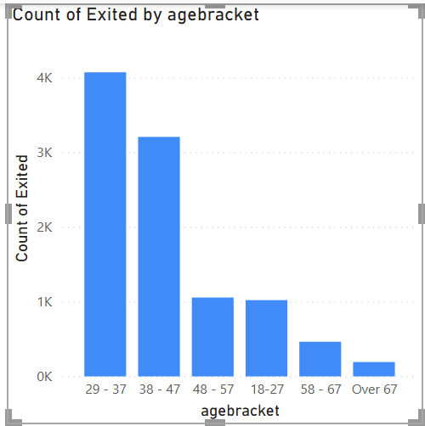

Insights:
- The 29–37 age group has the highest number of exited customers.
- The 38–47 age group has the second-highest count.
- Customers over 67 have the lowest exit count.
- These are raw counts; without each age group's total customer count, we cannot determine which group has the highest churn rate or financial risk.
Conclusion:
Customers aged 29–47 account for the largest observed numbers of exits. The bank should investigate their churn reasons and compare age-specific churn rates alongside balances, credit scores, and other financial indicators before classifying them as the highest-risk segments.

5. How would you use the available data to model and predict the lifetime (tenure) value in the bank of different customer segments?
Answer:
Customer tenure can be analyzed across demographic groups to understand how long customers typically remain with the bank. The chart shows that average tenure varies slightly across age brackets, ranging from approximately 4.84 to 4.89 years.

Visualization:
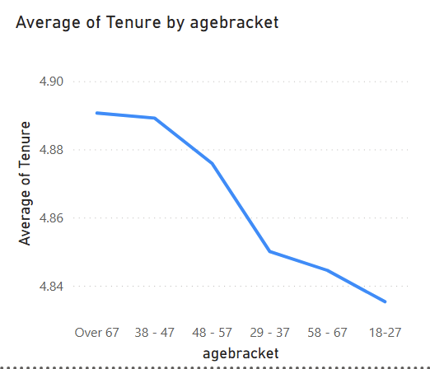

Insights:
- Customers aged over 67 have the highest average tenure, at approximately 4.89 years.
- Customers aged 18–27 have the lowest average tenure, at approximately 4.84 years.
- The differences between age groups are small.
- Average tenure alone is insufficient to predict customer lifetime value; balances, product usage, and churn status should also be considered.
Conclusion:
Age-based tenure analysis provides an initial view of customer retention patterns. The bank can develop a customer lifetime value model by combining tenure with account balances, product usage, and churn-related factors to estimate the long-term value of different customer segments.
6. How could you assess the impact of marketing campaigns on customer retention and acquisition within the dataset? What extra information would you need to solve this?
Answer:
Marketing campaign effectiveness can be assessed by comparing customer acquisition and retention before and after campaigns. However, the current dataset does not contain marketing campaign details, so the direct impact of campaigns cannot be measured.
Insights:
- Compare customer churn rates before and after marketing campaigns.
- Measure the number of new customers acquired through each campaign.
- Compare retention rates between customers who received campaigns and those who did not.
- Campaign dates, campaign costs, customer participation, and response data are needed for a reliable assessment.
Conclusion:
The bank can evaluate marketing effectiveness by combining customer churn data with campaign-related information. This would help identify which campaigns attract new customers and improve customer retention.

7. Can you identify common characteristics or trends among customers who have exited that could explain their reasons for leaving?
Answer:
The chart compares average credit score, credit card count, and total number of products by exit status. However, the current visual combines measures with different scales, making direct comparisons difficult.
Visualizations:
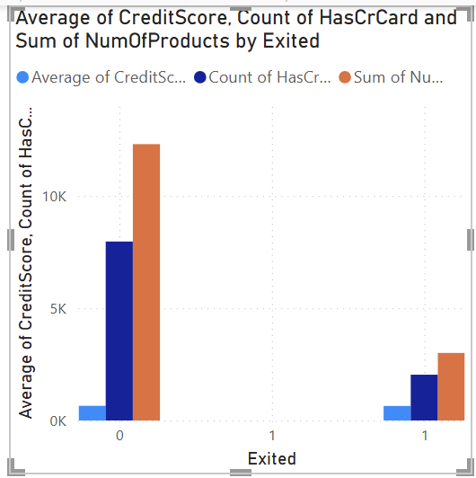

Insights:
- The chart suggests differences in product-related measures between retained and exited customers.
- The measures use different scales, so the current chart does not support reliable comparisons.
- The reasons for customer exits cannot be confirmed from these variables alone.

Conclusion:
Customer credit scores, credit card ownership, and product usage can help identify patterns associated with churn. Separate charts or appropriately scaled measures would make comparisons clearer. Additional information, such as customer feedback and exit reasons, is needed to determine why customers leave.

8. Are Tenure, NumOfProducts, IsActiveMember, and EstimatedSalary important for predicting if a customer will leave the bank?
Answer:
Yes, these variables can help identify patterns associated with customer churn. Tenure reflects the length of the customer relationship, number of products indicates product usage, active-member status reflects engagement, and estimated salary provides financial context. However, their predictive importance must be tested using data analysis or a predictive model.
Insights:
- Tenure: Helps examine whether customer retention varies with relationship length.
- NumOfProducts: Helps identify differences in churn across product-usage groups.
- IsActiveMember: Helps assess whether engagement is associated with retention.
- EstimatedSalary: Can be tested to determine whether salary contributes useful predictive information.
Conclusion:
All four variables are potential predictors of customer churn, but their actual importance cannot be confirmed from the available charts alone. A classification model, such as logistic regression or a decision tree, can assess their predictive contribution and help the bank identify customers at risk of leaving.

9. Utilize SQL queries to segment customers based on demographics and account details.
Answer:
Code:
with ageseg as (select customerid,
case when age between 18 and 29 then "18-29"
when age between 30 and 49 then "30-49"
else "50+" end as age_bracket
from customerinfo)

select a.age_bracket, round(avg(b.tenure),2) as avgtenure
from ageseg a
join bank_churn b
on a.customerid = b.customerid
and b.exited = 1
group by a.age_bracket;

Results:
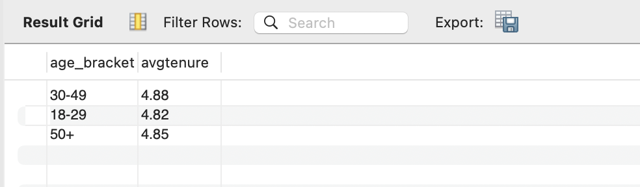

10.How can we create a conditional formatting setup to visually highlight customers at risk of churn and to evaluate the impact of credit card rewards on customer retention?
Output:
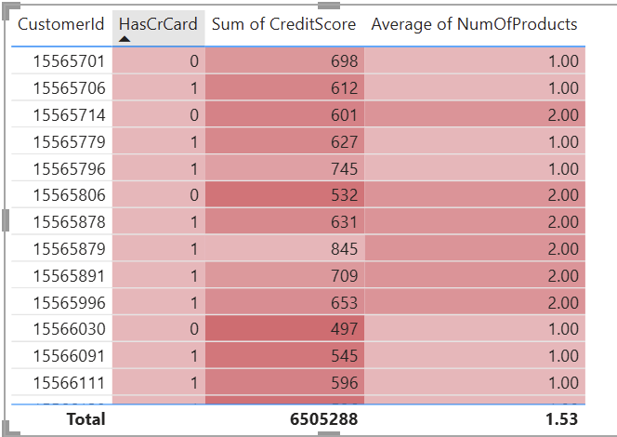

11. What is the current churn rate per year and overall in the bank? Can you suggest some insights to the bank about which kind of customers are more likely to churn and what different strategies can be used to decrease the churn rate?
Answer:
The overall customer churn rate is 20.37%, with 2,037 customers having exited out of 10,000 customers.
To complete the year-wise analysis, please share your Power BI chart or SQL output showing the churn rate for each year. I’ll use those actual results in the report.

Insights:
- Female customers have a higher churn rate (25.07%) than male customers (16.46%).
- Inactive members have a higher churn rate (26.85%) than active members (14.27%).
- Customers without a credit card have a slightly higher churn rate (20.81%) than those with one (20.18%).
Recommendations:
- Introduce targeted retention campaigns for customer groups with higher churn rates.
- Improve engagement with inactive customers through personalized communication and relevant offers.
- Investigate why female customers are leaving at a higher rate.
- Monitor churn rates regularly to measure whether retention strategies are working.
Conclusion:
The overall churn rate of 20.37% indicates that customer retention needs attention. Focusing on inactive members and other high-churn segments may help reduce customer exits. Year-wise churn results are needed to identify trends over time and complete the analysis.

12. Create a dashboard incorporating all the KPIs and visualization-related metrics. Use a slicer in order to assist in selection in the dashboard.
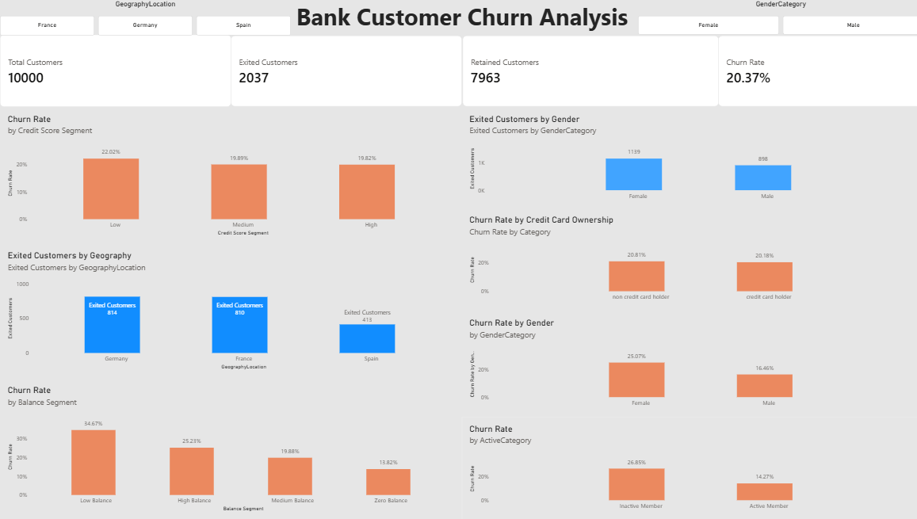

13.How would you approach this problem, if the objective and subjective questions weren't given?
- Find churn pattern by analysing the data
- Incorporate plans to retain the customers

14.In the “Bank_Churn” table how can you modify the name of the “HasCrCard” column to “Has_creditcard”?
- Go to data section, click on the 3 dots of the “HasCrCard” column and click rename option

